Mother Mary Lange O.S.P.
Prayer Service and Pilgrimage
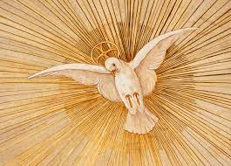

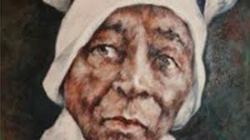

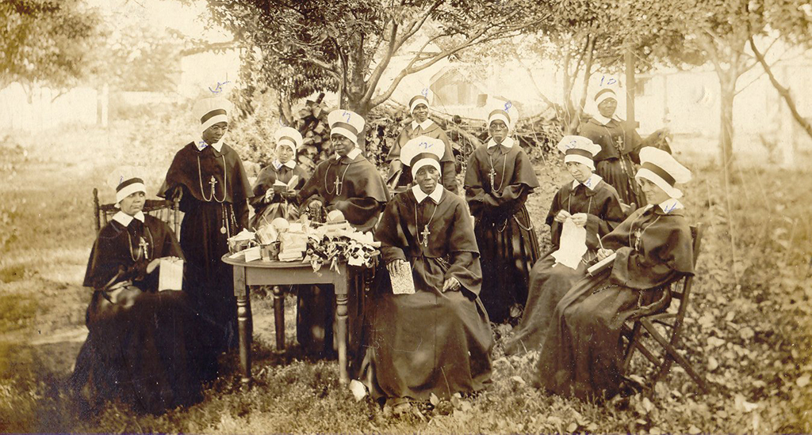
Oblate Sisters of Providence
Oblate Sisters of Providence
Oblate Spirituality, founded in and relying upon a loving Providence, is revealed in a deep, personal relationship with God and a manifestation of love, trust and respect for all.

(3-5 minute reflection of who are the Oblate Sisters of Providence
Oblate Sister of Providence Sr. Marcia Hall, O.S.P.
Your Attitude must be that of Christ
Philippines 2:5
Call to Prayer:

Leader: Our help is in the name of the Lord
All: Who made heaven and earth
Leader: Praise to you Lord our God, Ruler of the Universe, creator of light and darkness, Giver of Peace and compassionate maker of all good things.
All: We bless you, Lord our God, for your gifts, great and small. We ask that you bless us with Christ-life attitudes of care and concern for each other.

Video: https://www.youtube.com/watch?v=OYSZfA-0OUk
Opening Song: (Here I am Lord ) (4.5 min) https://www.youtube.com/watch?v=uylFDx0HvoY

Response to Love
(Joan Sattler and Delores Moore)
Response to Love is the title of the Oblate Sisters of Providence Constitution and Directives, “the roadmap of a pilgrim people as we make our way to the arms of a loving and providential Father.” These guidelines express the legacy of Mother Mary Lange, the Providence spirituality with which the Sisters serve humanity in response to today’s needs.
Imbued with the spirit of Mother Mary Lange, they continue to live and serve trusting in God’s providence.
Courage and holiness took root in the heart of a young woman, Elizabeth Clarisse Lange. How these qualities were planted and nourished remain a mystery. We see the fruits of her life and her community are intertwined and give the picture of her spirit at work. This prayer service is an opportunity to get a glimpse into the spirit which sustained her and can strengthen us today.
Joining other refugees in Baltimore she encountered racism in a slave state. Though free she shared the marginalization of African Americans.
After meeting Sulpician Farther James Hector Nicholas Joubert, who championed the education of African Americans, Elizabeth Lange’s dream of consecrated life was realized in the founding of the Oblate Sisters of Providence.
The Latin word Oblata indicates complete dedication, “not only to sanctify themselves and thereby secure the greater Glory of God, but also to work for the Christian education of children.” God’s Providence would be her mainstay. (Timeless Wisdom: Mother Lange Said...)
Let the peace of Christ rule in your hearts, since as members of one body you are called to peace. And be thankful. Let the message of Christ dwell among you richly as you teach and admonish one another with all wisdom through psalms, hymns, and songs from the spirit, singing to God with gratitude in your hearts. And whatever you do, whether in word or deed, do it all in the name of the Lord Jesus giving thanks to God the Father through Him.

Intercessions: (Cathie Kelly)
Leader: Lord Jesus, you emptied yourself for each of us. During this time of so much disorder in our lives, our hearts and our land, Hear us now as we pray.
For the times that our thoughts, words nor actions failed to demonstrated our awareness of your presence among us. We pray.
All: We beseech you O Lord, Hear us.

Leader: Lord Jesus you gave us Mother Mary Lange who surrendered her entire being to you. Mother Mary Lange formed the Oblates Sisters of Providence as role models of following your lead when the path is unpaved. Guide and sustain us into your light we pray.
All: We beseech you O Lord, Hear us.
Leader: For our children that their experiences and their lives overflow with a hunger for knowledge and opportunities that feed their budding curiosity for a better world for this we pray.
All: We beseech you O Lord, Hear us.

Leader: Lord Jesus, for an end to the violence of disease, gunshots, war and relationships that are within and/ or surrounds our thoughts our words our lives and those around us. We pray.
All: We beseech you O Lord, Hear us.
Leader: We pray for everlasting Peace. Peace in our lives, peace in our communities and peace in our World.
All: We beseech you O Lord, Hear us.
Leader: Lord we lift our hearts to all those who travel across the elements as refugees or immigrants. We ask that we maintain a spirit of hospitality and offer them safe space to exercise their human rights. We pray.
All: We beseech you O Lord, Hear us.
Leader: For an end to racism, sexism and all forms of abuse that chain our minds to indifference, silence or mindful ignorance. We pray.
All: We beseech you O Lord, Hear us.
Leader: For an end to the pandemic and an equitable access to
Healing or preventive resources we pray.
All: We beseech you O Lord, Hear us.

Leader: That we open our minds, our hearts and our spirit to be open to the grace you offer to us today.
All: We beseech you O Lord, Hear us.

Leader: That we lay all of these intentions and the intentions we ponder deeply in our hearts before you, we
pray.
All: We beseech you O Lord, Hear us.
Prayer: Lord Jesus we us come to you in gratitude, open to your mercy, your grace and you everlasting love. Draw us closer to you as we open our hearts and mind for you to feed our spirit, feed souls. Help us to be attentive to the movements within each of us that draw us closer to you. Abide in us O savior. Abide in us.

Song : (I Love the Lord) (5.5min)
https://www.youtube.com/watch?v=9E5e1TpEqb4

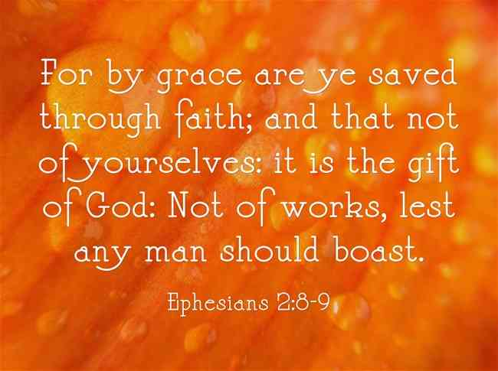

“The will of God will not take us where the grace of God cannot sustain us.”

(3-5 minute personal reflection) (Dr. Camille Brown)

Reader: Mother Mary Lange served the poor, the uneducated, the elderly and the sick. She did not hesitate to serve in a menial position in a seminary when such services would be a means to advance and continue God’s work.
All: Lord Jesus, help us respond to the poor and
Marginalized you call us to serve in our church and our community.

Song: (I just can’t give up now)
https://www.youtube.com/watch?v=xQj66oZue14

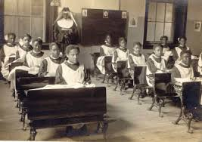

Mother Lange said,” My sole wish is to do the will of God.”
First Reader (Isabelle Micaela Garcia)
Reader: The first call of a servant is to listen to the spoken word. Let the power touch the core of the servant’s heart, to purge your soul with the fire. The word has become united with the servant’s life. When once that was spoken now takes on flesh and Christ is made visible. The needs of others call us to be sources of life- to be light in the dark.
We are called to be a spark that enlightens and warms as we share human goodness and wipe away encrusted surfaces of pain, injustice and degradation and fear.

All: Mother Mary Lange pray for us.

(3-5 minute personal reflection)

Song: ( I surrender all) (3.5 min)
https://www.youtube.com/watch?v=7x2IpLSfqp8
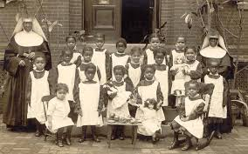

Mother Lange said: “We wish to follow the rules by which we live and are known to be sisters.”
Second Reader (Joe Hillary)

Reader: Elizabeth Lange listened to the call of God. He called her to follow. The circumstances of her traveling from San Dominique and from Cuba to Baltimore, Maryland are not important. The circumstances are only the instrument God used to accomplish his design. He wanted her here. He called her and she followed. He called and she came. Led by the Spirit, she came.

Reader: Reflect silently. Think of the time God called you. Listen. Respond as did Samuel, “Speak Lord, your servant is listening.”

Song: (How Great Thou Art) (5.5 min)
https://www.youtube.com/watch?v=OcjDoMJBbu4

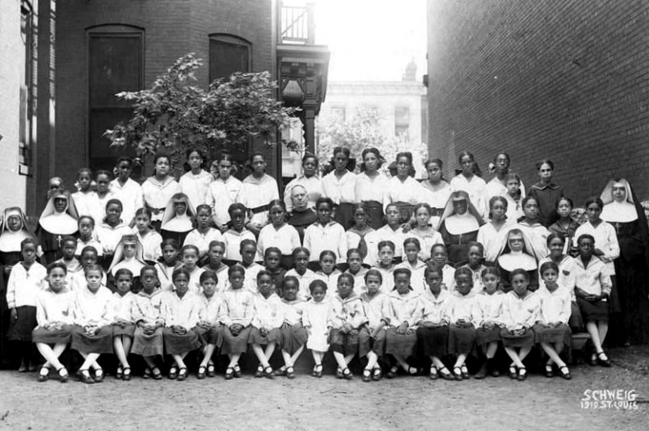

Third Reader (Michael Lance Barrett)

Reader: Mother M Lange listened to the will of God. God spoke and she obeyed. She used her own money to open a school for children that were abandoned. She listen and responded to the Spirit within her. “ She who instructs others to justice shall shine as stars for all eternity.” (Daniel 12:3)
Consider. Instructing others to Justice is sharing the Good News. It is each one of us individually and collectively telling us that God loves all of us. Mother Mary Lange shared the Good News through education. In her school she led the children and the sisters to discover Go’s love and God’s enduring providence. He provided all their needs. And I, do I worry about tomorrow? Do I know that God cares for me?
All: Mother Mary Lange intercede for us.
Song: (Jesus you’re the Center of my Joy) (5.5 min)
https://www.youtube.com/watch?v=Mq6hprGOxpY

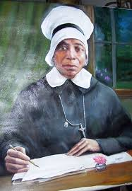

Fourth Reader (Ryan Sattler)
Reader: Like David, Elizabeth Clarisse Lange was called to serve as leader. (Kings 3:4-13) Like the Apostles she experienced the height of success and the depth of frustration. She sought to live a life dedicated to the service of her brothers and sisters in Christ. As a woman consecrated to God – a Woman Religious- she became known as Sr. Mary. Sr. Mary Lange lived the Beatitudes and reaped the reward – even on earth- for having lived a life of lowliness. Sorrow, mercy and persecution, now she can rejoice and be glad for her reward in heaven is great. (Pause)

Reader: Think! Am I merciful to all or am I only merciful to those who are merciful to me? Am I forgiving or do I just write off those who have wronged me? Do I listen to the cry of the unborn? Do I cry over those shot senselessly in our streets? Do I hurt as their loved one hurts? Do I reach out to them? Do I have a deep hunger for justice? What do I do to achieve peace and justice in my family, in my Church, in my community?
Song: (My Help) (8min)
https://www.youtube.com/watch?v=k47xB8eoT5g

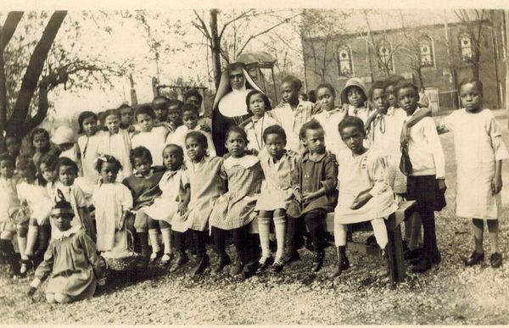

Fifth Reader: (Grace Byerly)
Reader: Mother Lange’s Life as a refuge with the language barrier – a black woman in a slave state before the Emancipation Proclamation – a Catholic woman in an era of anti-Catholic sentiment- demonstrates concretely her strong and sterling character, She is the woman who by the grace of God allowed life’s situations to depend more on providence and mold not just into a strong woman, but a holy woman who consistently committed her life to others. It is this latter that has sparked interest in investigating the relevancy of her life and the inspiration she offers to men and women of the 21 century.
Consider: What the Lord has done for Mother Mary Lange, he will do for me. It is the Lord who is my light and my Salvation.
Sing together: “The Lord is my Light and my salvation, the Lord is my light and my salvation, the Lord is my light and my salvation, the Lord is my light and my salvation whom shall I fear.”
Reader: Mother Lange served the uneducated, the poor, the disenfranchised, the elderly and the sick. She did not hesitate to serve in a menial positon in the seminary when such serve would be a means to advance God’s work.
All: Jesus meek and humble of heart; make my heart like into thine. Mother Mary Lange pray for us.
Reader: Mother Mary Lang suffered acutely when her close companion and one of the first four Oblates left the community thinking that all was lost in the infant community after the death of their co-founder Fr. Joubert.
Consider: What is the cross I carry- either by the direct will of God our Father, or as a consequences of the choices I have made. (pause)
All: Lord Jesus, we share your passion and death when you purify us in the crucible of suffering. Help us to be steadfast and grant us the grace to love you always.
Lord, through the intercession of Mother Mary Lange may we glorify our trust in providence and submit to all it decrees.
Song: Mercy said No (5.5 min)
https://www.youtube.com/watch?v=JQaOl7qH31w

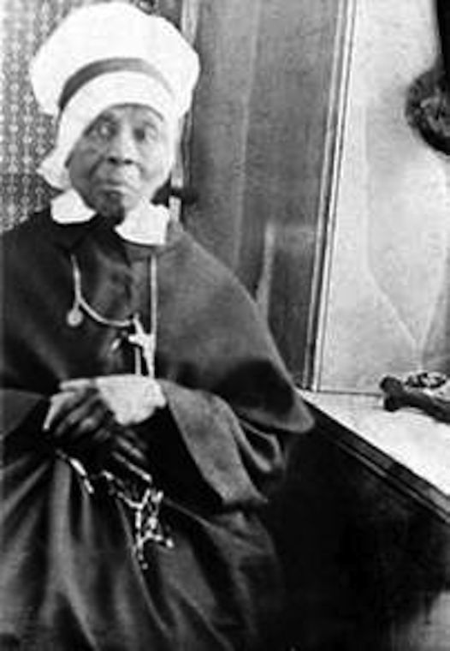

Sixth Reader (Elaine Crawford)

Reader: Mother Mary Lange lay dying as a young novice in the chapel was pronouncing her vows. Unless a kernel of wheat falls into the ground and dies, it remains only a single seed. But if it dies it will produce many seeds.
(John 24:24) Now more than 175 years later, Oblate Sisters of Providence following the example of their foundress, Mother May Lange through education, the Spanish apostolate, catechesis, child care, human services to youth, the aged and the poor. Oblate Sisters engage in pastoral and social ministries in the United States, Costa Rica and Central America.
All: The Lord has done great things for us all.

Song: (Total Praise) (8.5Min)
https://www.youtube.com/watch?v=ZME9t4nsCrc
(3-5 minute personal reflection)
The one who ponders the Law of the Lord Day and Night
Will yield fruit in due season. Psalm 1:2-3

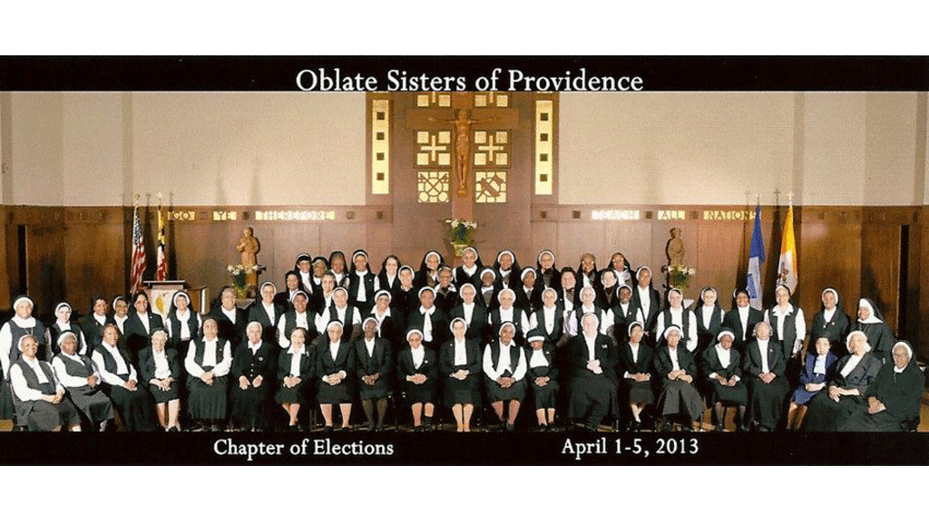
Currently the order has approximately eighty members. The Oblate Sisters continue in Baltimore, Maryland and Costa Rica.

PRAYER FOR THE CANONIZATION OF MOTHER MARY LANGE
O Almighty and Eternal God, You granted Mother Mary Lange extraordinary trust in your providence. You endowed her with humility, courage, holiness and an extraordinary sense of service to the poor and sick. You enabled her to found the Oblate Sisters of Providence and provide educational, social and spiritual ministry especially to the African American community. Mother Lange’s love for all enabled her to see Christ in each person, and the pain of prejudice and racial hatred never blurred that vision. Deign to raise her to the highest honors of the altar in order that, through her intercession, more souls may come to a deeper understanding and a more fervent love of You. Heavenly Father, glorify Your heart by granting also this favor (here mention your request) which we ask through the intercession of Your faithful servant, Mother Mary Lange.
Closing Song: O Happy Days (3 min)
https://www.youtube.com/watch?v=6PQvH6la9QI

